ENTEBBE BRIGHT SECONDARY SCHOOL
BEGNNING OF TERM 3 EXAMINATIONS 2022
S.3 GEOGRAPHY PAPER 2
Time: 1$1/2$hrs
PART 1: THE REST OF AFRICA
Answer two questions from this paper
- Study Figure 1 map of Africa provided showing climatic regions and
answer the questions that follow:
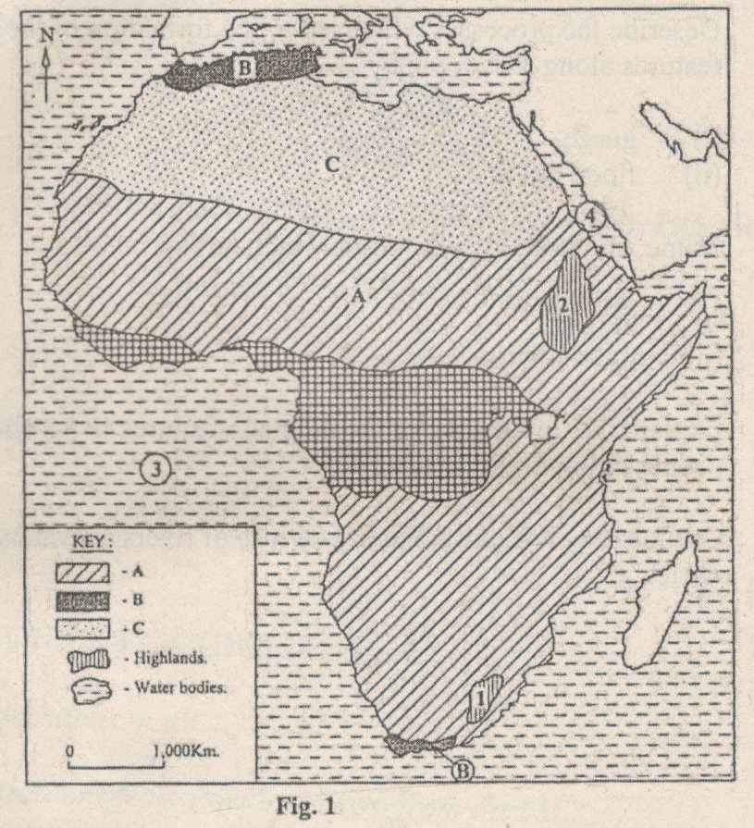

(a) Name the:
(i) climatic regions types marked A, B and C. (03 marks)
(ii) highlands marked 1 and 2, (02 marks)
(iii) water bodies named 3 and 4. (02 marks)
(b) Describe the characteristics of any one type of climatic region named in
(a) (i) above. (08 marks)
(c) Explain the conditions which have influenced the distribution of
climatic regions in Africa. (06 marks)
(d) Outline the problems faced by people living in areas of the climatic
station given in (b) above. (04 marks)
PART II
STUDIES OF DEVELOPMENT
Answer two questions from this PART.
REGION I NORTH AMERICA
5. Study Fig 3: map of British Columbia provided below and answer the questions that follow:
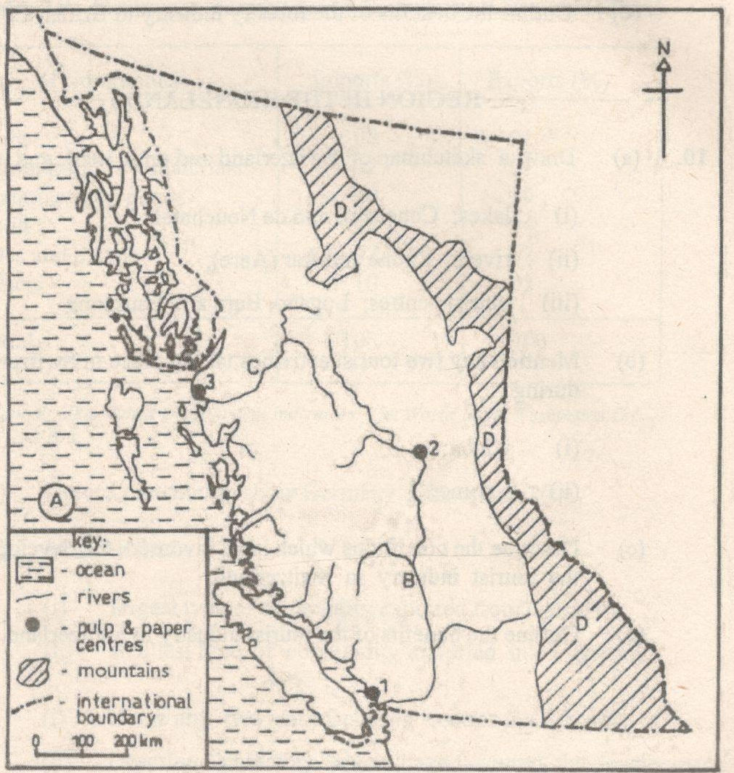
(a) Name the:
(i) Ocean marked A.
(ii) rivers marked B and C.
(iii) mountain marked D.
(iv) pulp and paper centres marked 1,2 and 3. (07 marks)
(b) (i) Identify any three types of trees used in the pulp and paper industry
in British Columbia.
(iii) Describe the characteristics of forests in British Columbia.
(c) Explain the factors which have led to the development of anyone pulp
and paper industrial centre marked in (a) (iv) above.
(d) Outline the benefits of the forestry industry to British Columbia.
- (a) Draw a sketch map of the New York city and on it mark and name;
- Islands: Staten, and Manhattan
- Rivers: East and Hudson
- Airports: LaGuardia and J.F Kennedy
- Atlantic Ocean (8 marks)
(b) Describe the conditions that led to the establishment of the New York Port or city
(c) Outline the functions of the New York City.
(d) Explain the environmental problems which have resulted from the development of New York
City.
- (a) Identify any two;
- states in the New cotton belt
- states in the Old cotton belt
- industrial centres in the new Cotton belt
- industrial centres in the Old cotton belt (8 marks)
(b) Describe the factors that led to the establishment of the New Cotton belt. (6 marks)
(c) Explain the challenges experienced in the cotton growing areas in the South (6 marks)
(d) Outline the steps being taken to address the challenges in (c) above.(5 marks)
END.

